1. 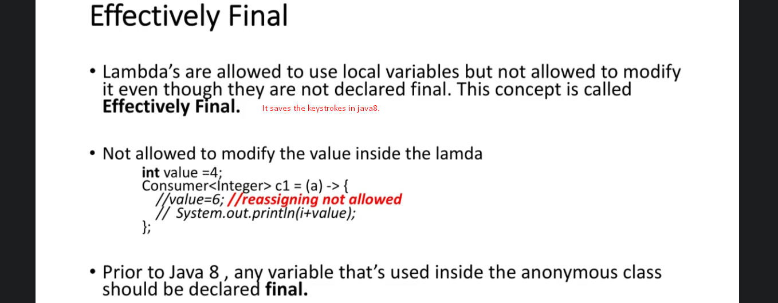
2. 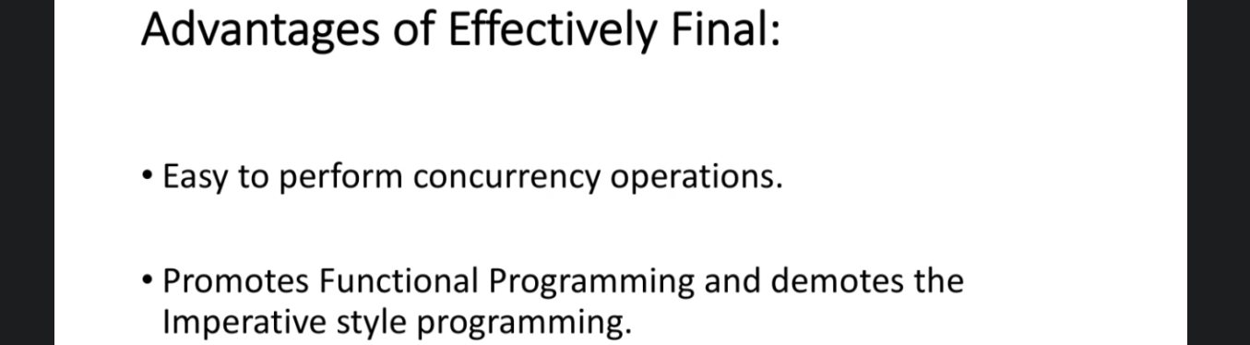  
   **Why Easy to perform concurrency operation**: If the lambda expression is being used in more than one thread, due to effectively final variable, no race condition.